I, Name: …………………………………………………………………..

Yes, I agree **✓** to being: (please circle) or I do not agree **X**

Taped (Audio) Videoed Photographed

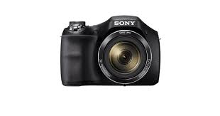



This can be used for: **YES** **NO**

|  |  |  |  |
| --- | --- | --- | --- |
| **reward** | Supporting my personal learning and development programmes. | **✓** | **X** |
| **staff traing** | For Company (COMPANY NAME) staff training | **✓** | **X** |
| **C:\Users\Caroline Fitzgibbon\Desktop\training.jpg** | Staff training with external agencies (to improve and develop professional skills) | **✓** | **X** |
| **COMPANY LOGO TO GO HERE** | Company (COMPANY NAME) marketing material.  Online media (website, social media) Print media (brochures, posters) | **✓** | **X** |



Recordings will be PASSWORD PROTECTED to keep

them safe.

I can choose to have the recordings destroyed at any time if I want to.

I have understood and agree with this**✓**

Signature: ………………………………………….. Date: …………………………

Or

I, as the appointed relative/carer, agree to this on behalf of: ………………………..

Name: ………………………………………………

Signature: …………………………………………. Date: …………………………